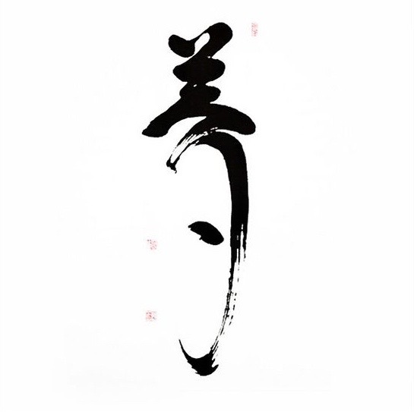

Japanese Zen Meditation

“Do not follow ideas of others, but learn to listen the voice within yourself. Your body and mind will become clear and you will realize the unity of all things”
Zen Master Dogen (1200-1253)

Every Sunday
Shen Dao center
17.30 – 19.00
50 kr for person

17.30 - Introduction to Zazen (sitting meditation)– 20 min

18.00 – Zazen – 2 sessions, each 25 min with 5 min Kinhin (walking meditation)

19.00 – Tea is served before the end

*Event is held in English. Swedish offered if needed

Zazen is 1200 years old meditation practice which belongs to Zen tradition. Zen doesn’t believe in anything. It only says “Observe and investigate carefully, who is the one who sees, listens, feels, thinks and experiences life here and now”. Therefore Zen promotes study of self

It helps us find freedom from identifications with our compulsive thoughts, emotions, worries and fears that we encounter in daily life. To let go of obsessive compulsive mind games, commentaries and inner dialogs. With practice we find that deep peace of mind, serene and balanced which has been within us since birth but buried underneath manifold layers of our ego. As we sit we gradually get back in touch with our original self. Our awareness is bright, clear, free and simple without additions

After long dedicated practice we may even find answers to basic questions of life. Such as what are we searching for? Why we feel sense of lack and incompleteness? Why there is not joy in our life but only moments of it? Why we search love and connection with another human being? What is a meaning of our existence? Who am I truly? And many other questions.

Zen is a timeless practice, which for centuries, has been offering humans answers to basic questions of life. Not as a knowledge but as a intimate understanding that reveals itself by practicing Zazen. In today’s modern world Zen is truly a beautiful gift to humanity, promoting life of awareness, compassion and sincere care for all fellow beings.

Marko D. Simeunovic has been practicing Zen for more than 10 years. Yearly he travels to Japan where lives and trains in Rinzai Zen Monastery in Okayama. The training is led under instruction and supervision by one of the greatest living Zen masters of our time Shodo Harada Roshi. Several times per year he also attends sesshin (zen retreats) held in Germany. When time and circumstances allow, Marko spends time in solitary retreats in Dordorgne France. He had spent some period of time in Himalayas where learned about self inquiry and meditation from Tibetan masters.

Today he practices as a Medical Doctor at Department for Cardiothoracic Surgery at Akademiska University Hospital.

“Working with people I have noticed alarming degree of stress in today’s society and lack of skills to cope with it. Zen and other body-mind practices have never been of so great importance than now”

“My heartfelt wish is to try help others develop rather stable, open, peaceful and resilient mind which gradually leads to more harmonious way of life”
